1. Find YBUS of power system shown in figure below.

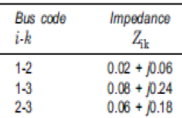 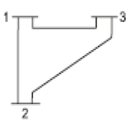

 

1. Find YBUS of power system.

